US T-Bill price decline analysis
June 22, 2026
Derek Ding

- Data Description

Source: St. Louis Federal bank website.
Index Name | Data Frequency | Data Type | Start Date | End Date
3-Month Treasury Bill Secondary Market Rate  (ticker: DTB3) | Daily | Yield | Jan, 1954 | Jun, 2026
U.S. Treasury Securities at 3-Month Constant Maturity  (ticker: DGS3MO) | Daily | Yield | Sep, 1981 | Jun, 2026

- Price Decline Analysis
  - Method 1 – historical 5-day price decline analysis
In this method, we initially convert yield to price. Subsequently, we calculate the 5-day price decline on a rolling basis for aformentioned 2 T-bill 3-moth rates. The values representing price decline at selected critical quantiles are presented in the first table below.

 | 3M Tbill  (secondary market) | 3M Tbill  (constant maturity)
Data Range | Jan 1954 - Jun 2026 | Sep 1981 - Jun 2026
Max | 0.490% | 0.363%
99% | 0.135% | 0.094%
95% | 0.055% | 0.043%
90% | 0.035% | 0.026%
50% | 0.000% | 0.000%

  - Method 2 – closed-form calculation (auxiliiary proxy

Example 1: rate change – 1% to 4%
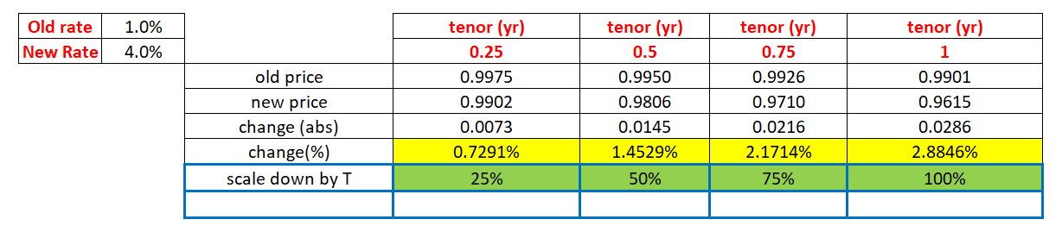
Example 2: rate change – 1% to 2%
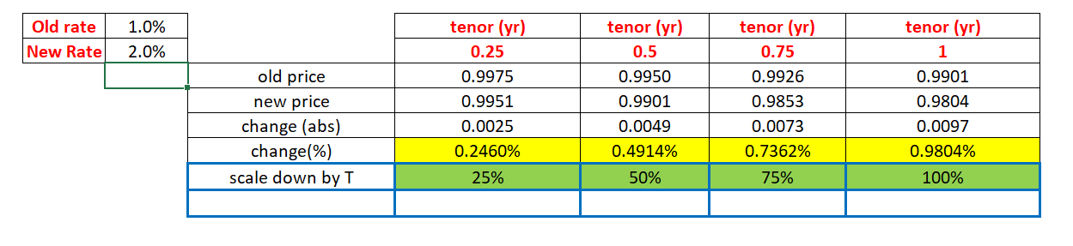
As indicated by the preceding results, the relative change (%) exhibits linearity with respect to time (t)

- Proposal

Based on abaove result ,

